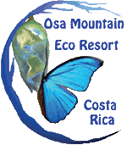

**TRAVEL TIPS**

**For Your Stay in the Rain Forest**

**Toucan Valley/**

**Osa Mountain Village**

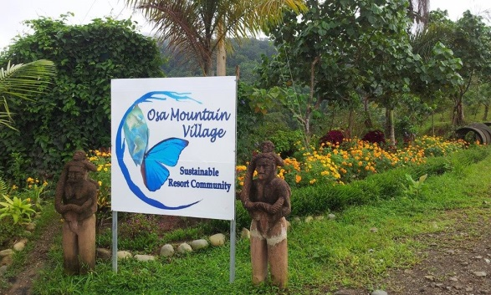These Travel Tips have been put together to help you plan a smooth, easy, pleasurable and exciting visit to Toucan Valley at Osa Mountain Village Eco Resort.

**San Jose International Airport:**You’ll want to fly in to San Jose - Juan Santamaría International Airport - located in the Central Valley of Costa Rica.

**Navigating the Airport:**

After you exit your plane, Immigration wants to see your passport and the completed forms the airline gave you on the plane. They may ask you for your return ticket (to ensure that you’re not staying), ask a few questions and check your passport, but it is a friendly, easy formality to get a 90-day visa.

In the baggage claim area, you can grab a free cart for your luggage.

Here you can also exchange money (see “Money” below), buy phone cards or SIM chips for your phone (see “Cell Phones” below).

You will also find a duty-free store where you can purchase items at significant savings, especially if you plan to buy any alcoholic beverages during your trip.

Have your plan of travel in place when leaving the airport, because the area outside can be chaotic, with all sorts of folks offering you a taxi and other services. Use common sense and always keep an eye on your bags and personal belongings. It’s never a bad idea to ask two different taxi drivers for a price, to ensure that you are not being over-charged, IF you need a taxi. It is here that you will meet your hotel shuttle if spending the night in San Jose.

Taxis and car rental agencies accept U.S. dollars. Taxis are inexpensive. Many car rental agencies and some hotels offer free shuttles, so check with them before you arrive and make plans accordingly.

**Travel from the airport to Osa Mountain Eco Resort:** From San Jose Airport, you have the option to rent your own car and drive, fly a regional airline, hire a shuttle, or take public transportation.

It is a 4+ hour drive from the airport to Osa Mountain Village Eco Resort, so if you land in San Jose after 1:00 PM, and you drive it yourself, we recommend that you spend your first night in San José, because it gets dark at 5:30 PM and the last part of your drive can be tricky, if you don’t know it.



* **Adventure Inn**

is a conveniently located and nice hotel near the airport.

They will pick you up at the airport. **To reserve and get a 10% discount, go to:** <https://www.adventure-inn.com/promo/OSAMOUNTAIN>

Make sure you secure a shuttle. Pay in cash and receive an additional 10% off upon arrival when you check in!

* **Margarita’s -** <http://margaritaguesthouse.blogspot.com> – If you’d like to save some money and have a local experience, this is your spot. Lodging is between $30-$40/night, depending if you want home-cooked meals included. Its clean and friendly and only a few minute taxi drive from the SJ Airport. There is no TV in your room and you might share a bathroom, so if you don’t mind those things, you can save yourself some money.

**Car Rental**

We’ve only recently begun to recommend any particular company for a car rental, but there became a huge need to find someone with a complete ‘out the door’ price after numerous guests complained about the company(s) they booked with online – only to arrive, tired, ready for their car, with *huge additional fees* added on. For an up to date car referral, please email Patricia at [GroupToursCR@gmail.com](mailto:GroupToursCR@gmail.com). Our goal is to ensure you know exactly what you’re getting when you reserve, and the exact price, from a local reputable company. Please email if you need car rental information.

If you want the convenience of having your own car (you do!), you can rent a car and take the beautiful drive to Osa Mountain Village Eco Resort in the South Pacific zone. (See map and directions below.) Make your car reservation before you get to Costa Rica and make sure you get a **4-Wheel Drive**. As we like to say, “*Anything worth seeing in Southern Costa Rica is either at the end of a dirt road or at the top of a mountain.”* Spectacular stuff. Not to mention the fact that you likely never make it up our mountain without one.



The easiest route from the airport is heading for San Jose. After a 15-minute drive, you’ll come to a major intersection. There you will turn right and west, on to **CR 27.** After about an hour, just after the 4th Toll Plaza, take the **Exit to CR 34 and Jaco** and stay on Rt. 34 for about 3 hours.

The road leading to Osa Mountain Village Eco Resort is located 35km south of Uvita, but first, you’ll want to make a stop at one of the two **BM Markets** in Uvita, on the main road, on your left. Here you can stock up on necessary food and drink for your villa. There is another BM Market close to the base of our mountain, but you’d have to pass our entrance to get there, so this is the best place, right on your way, to stock up. We suggest that you look for the local brand names rather than the North American names you’re used to. These ‘familiar’ items can cost a great deal.

**Please Note:** Depending upon the time of year and our occupancy rate, The Rainforest Bar (with food options) may/may not be open every day during your stay. Email Patricia at [GroupToursCR@gmail.com](mailto:GroupToursCR@gmail.com) for information regarding the availability of this during your stay. You are invited to participate in our fruit/vegetable/egg bi-weekly distribution, or help yourself to the gardens at any time while you are here. You can whip up some tasty stir fry’s ….

After grocery shopping, continue south on the Costenera (Costa Rica Route 34) for another 20 minutes or so, and at **kilometer** **marker 196**, you will see a sign pointing left to “Osa Mountain Village” – take that left turn. If you see ‘The Osa Canopy Tour” sign on your right, you’ve just missed it. Turn around and make the first right turn after you pass The Canopy Tour sign.

Here you will find the gravel road that leads to Toucan Valley/ Osa Mountain Village Resort. You’ll make another left turn almost immediately, heading up the mountain. The road leading up to the resort is marked with several signs. It is about 7km from the highway.

**Easy Ride - Airport Shuttle** You can also take an Airport Shuttle to a nearby town. If you do, we recommend that you use the Easy Ride Airport Shuttle company: http://www.easyridecr.com, because they have great drivers, who speak excellent English. They do not bring you up our mountain however, but you can meet your rental car at a designated place along the way … Ojochal or Uvita is a good choice of cities along the main road, Ojochal being closer to OMV by about 10 minutes.

________________________________________

**Flying a Regional Airline:** You also have the option to take a local flight to a nearby city, but be aware that the commuter aircrafts that services these towns, have a luggage weight limit. If you go over the limit, you will be charged $1.00 for each additional pound.

The two regional airlines are Sansa Airlines and Nature Air. Sansa will fly you into Palmar Sur (very close to us) and Nature Air will fly you to Quepos (90-minute drive to the base of our mountain). It’s a gorgeous 40-minute flight, but check these airlines and flight times before booking your flight into San Jose. Depending on the time of year, there may be only one daily flight.

If you have a pre-booked rental car through us, they will pick you up at the local airport, but confirm this before booking.

**Public Transportation**: If you’re on a tight budget or just prefer to take a bus, for approximately $12 (roughly), you can get a bus from SJ Airport to Uvita. Just make sure to take the bus with the SHORTEST route if you want to get to us the quickest way possible. The other route is through the mountains and pretty, but it takes another two+ hours.

________________________________________

**Osa Mountain Village Eco Resort and Jungle Adventures**We have worked closely with our designers and builders to create a luxurious resort with options common to European and American standards, including completely furnished 1, 2 and 3 bedroom villas, with full kitchens.

Osa Mountain Village Eco Resort is secluded in the middle of the jungle and surrounded by old growth rainforest teaming with wildlife.

You can relax by the pool, while watching the monkeys and birds or take a hike to any one of the three waterfalls on our property. You might also choose to enjoy some of the best jungle adventures available, right here on our property; The Canopy Tour which has nine platforms, two bridges, two rappelling stations and an amazing Tarzan Swing finale, fishing, snorkeling, kayaking and amazing ‘hidden’ restaurants nearby.

**Prepare yourself for a ‘different’ kind of vacation**; a jungle experience! … due to our remote location, ‘expect the unexpected’. Our Internet is normally perfect, but there are times when it is ‘less than perfect’. If this situation occurs, a quick trip down the mountain and you can check in on your important emails and whatnot … again, this occurrence is rare, but worth mentioning.

We do all we can to ensure things roll smoothly, but at 2000 ft. elevation in a more remote part of Costa Rica, *in the jungle* … it happens. Occasionally we lose power briefly … *occasionally* it can be longer – again, very rare. These brief and infrequent occurrences sometimes leave our guests with the most beloved memories upon returning home. We grab candles, head to the bar (open or not) or community center, bring our own spirits, play music and enjoy the jungle with friends ☺ This exceptional vacation experience requires that you adapt a Pura Vida attitude and *you will not be disappointed*.

Most of our villas (not all) have a TV and DVD player. Most do NOT have cable however. **You can stream your Internet movies by bringing an HDMI cable**.**and connecting it to your laptop.** *We would rather however*, prefer to support you in spending your evenings on your deck, sipping some wine with new friends. It might be nice to consider ‘taking a TV break’ this vacation and commune with nature during your stay with us ☺

________________________________________

**The Rain Forest Club Bar** is a fun place to have a beer, a tasty cocktail, dinner … and play pool, ping pong and enjoy meeting other guests.

Your villa has all cooking utensils, plates, glasses and silverware you need to prepare and enjoy your meals, but there are no food, spices, salt or coffee stocked.

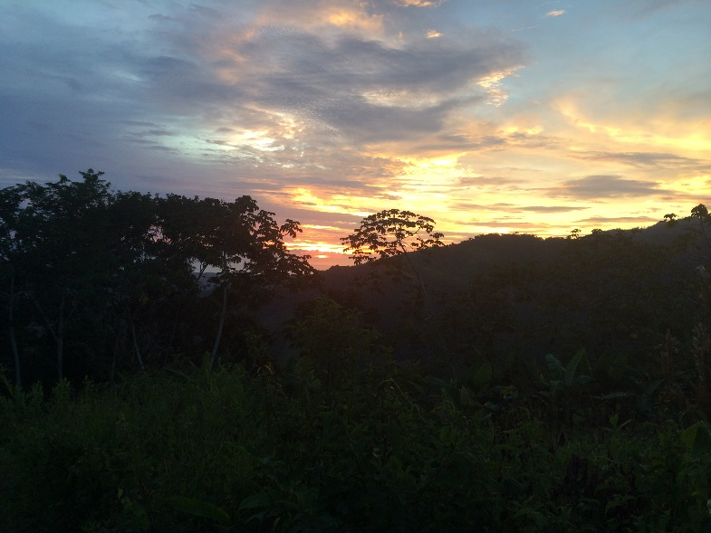

**Climate**Costa Rica is a tropical country situated between 8 and 11 degrees above the equator. It has only two seasons: dry and green! The dry season (called “verano” meaning summer) with very little rain is generally between late December and April and the green or wet season (called “invierno” or winter) lasts the rest of the year - May through November, but still offers an average of about 5-7 hours of daily sunshine. Temperatures range from 75°F at night to 95°F during the day with less humidity at Osa Mountain’s 2000 foot elevation. Light clothing is recommended for this warm climate although you should bring along some long pants and hiking shoes for when you visit the rainforest. Be sure to pack sun screen lotion for the daytime exposure. Some insect repellent may occasionally be needed in the early evening, but at this elevation, not so much.

**Money**In a nutshell, you get 500 Colones for 1 US Dollar. For example, ₵1000 Colones = to US $2. This is not a completely accurate conversion, but it is the easiest to remember and will serve you well.

US Dollars are accepted almost everywhere in Costa Rica, so you don’t need to exchange your money in the airport, but if you want to anyway, you have exchange places in the baggage claim. They have a low exchange rate. If you use US dollars to pay for something, your change will be in Colones.

We do not recommend Travelers’ checks since most merchants and hotels do not accept them and cashing them at a bank can be a long process...

The best seems to be to carry a reasonable amount of cash ($200-$400) and refill at the ATMs as you go. ATMs are located throughout Costa Rica and generally do not charge any fees, even though your bank probably does. Palmar Norte is only a 10 minute drive from the base of our mountain where you can go grocery shopping, liquor shopping, use one of several bank ATM’s, pharmacies, doctors, etc.

**Cell Phones**You can rent Cell Phones in Costa Rica, but you have to make sure they have the new 3G protocol, because only the 3G phones will work in the area of Osa Mountain Village Eco Resort.

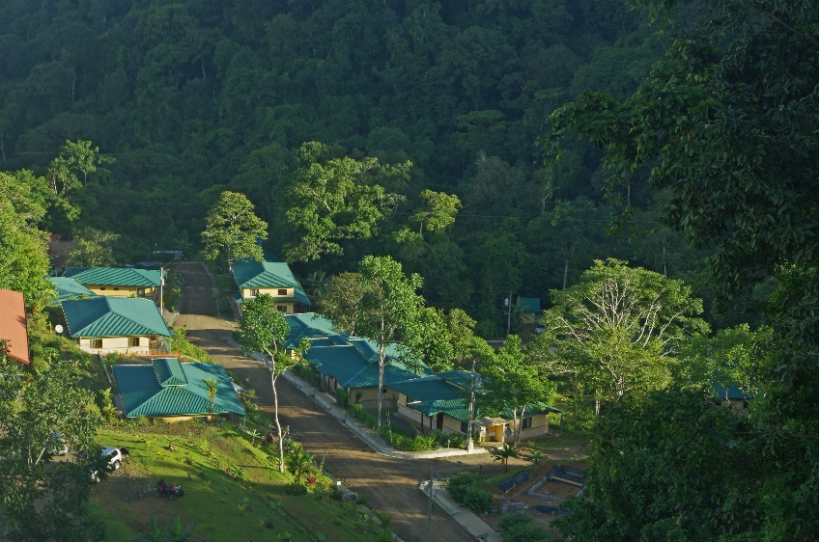

You can use your own 3G Phone if it can operate on the UMTS 3G 850Mz frequency. Before you leave your country contact your carrier and ask for the cost for international calling or request the ‘Unlock code’. **Once unlocked, you can purchase a prepaid SIM card for around $20. You can get them in the baggage claim area.**

**Pay Phones**If you are not going to have a cell phone, you can use a pre-paid phone card on the Public phones, which you can buy when you arrive at the ICE counter in the baggage claim area or in most grocery stores.

**Computers and the Internet**

You can find many places to access the Internet. The majority of these are also free! Using your laptop or Smart phone to make (Skype) calls is a good way to save money. Osa Mountain Village Eco Resort does have wireless internet access in most areas.

**Suggested items to bring:** Flashlight, waterfall hiking shoes (they will get wet). An HDMI cable for streaming from your device (no cable TV here) … and your adventurous spirit 😊

**Medical Insurance:** Many of our guests inquire about medical insurance. If interested in obtaining medical insurance while traveling abroad, we have found many of our guests are happy with this company: <http://www.internationalmedicaltravelinsurance.com>.

**Enjoy your stay with us in the rainforest, at Toucan Valley/Osa Mountain Village … your jungle adventure …. See you soon ☺**

